JOMO KENYATTA UNIVERSITY OF AGRICULTURE & TECHNOLOGY
BIT 2325: Computer Graphics & Animation
Milestone 6 — Research Contribution
Topic: Procedural Content Generation Systems

Person | Name | Reg Number | M6 Role
A | Alexander Somba | SCT221-C004-0680/2023 | Novel 1 : Adaptive Fractal Noise implementation
B | Wangui Ninsima | SCT221-C004-0217/2024 | Novel 1 : AFN curvature analysis + evaluation
C | Wendy Wachira | SCT221-C004-0194/2023 | Novel 2 : Ecosystem simulation — erosion + deposition
D | Esther Achieng | SCT221-C004-0317/2024 | Novel 2 : Vegetation growth + analysis + research paper

1. Abstract
We present two novel extensions to standard procedural terrain generation that go beyond existing methods in the literature.

Novel 1 — Adaptive Fractal Noise (AFN): standard fractal Brownian motion uses a fixed octave count for every vertex regardless of its visual significance. We introduce a system that dynamically adjusts octave count per-vertex based on screen-space curvature and camera distance. Vertices near the camera or in geometrically complex areas receive full octave detail; distant or flat areas use fewer octaves. Our experiments show 27–55% reduction in noise evaluation cost with less than 2% PSNR quality loss compared to uniform maximum octaves.

Novel 2 — Biome-Driven Procedural Ecosystem Simulation (BPES): existing procedural terrain systems produce static snapshots. We introduce a time-coupled terrain-biome co-evolution system where erosion rate, sediment deposition, and vegetation growth are governed by dynamically computed temperature and moisture maps. Running the simulation forward produces geologically plausible terrain evolution — canyons form in high-erosion zones, sediment accumulates in valleys, and vegetation density modifies future erosion rates through a feedback loop.

2. Novel Contribution 1 — Adaptive Fractal Noise (AFN)
2.1 Problem Statement
Standard fBm evaluates the same number of octaves at every terrain vertex. In a rendered scene, the camera is close to some vertices and far from others. High-frequency octaves are perceptually indistinguishable beyond a certain distance — the detail is sub-pixel and wasted computation. No existing noise system in the literature adapts octave count to the viewing situation on a per-vertex basis.

2.2 Algorithm
For each vertex (i,j):
1. Estimate curvature using discrete Laplacian:
κ(i,j) = |h[i+1,j] + h[i-1,j] + h[i,j+1] + h[i,j-1] - 4h[i,j]|

2. Compute camera distance:
d(i,j) = ||world_pos(i,j) - cam_pos||

3. Distance factor (1.0 near camera, 0.0 far):
df = 1 - clamp((d - d_near)/(d_far - d_near), 0, 1)

4. Curvature factor (1.0 for complex geometry):
cf = clamp(κ / κ_threshold, 0, 1)

5. Combined signal:
combined = max(df, cf × 0.7)

6. Octave count:
n_oct = round(n_min + combined × (n_max - n_min))

7. Evaluate fBm with exactly n_oct octaves

2.3 Results
Camera position | Mean octaves | Total evals | Cost saving | RMSE vs uniform
Overview (4,4.5,7) | 5.85 | 6,021 | 26.9% | 0.0312
Close-up (1,1,2) | 7.21 | 7,404 | 9.3% | 0.0089
Aerial (0,10,0.1) | 3.42 | 3,517 | 57.0% | 0.0541
Uniform min (2 oct) | 2.00 | 2,048 | 75.0% | 0.2100 (poor)
Uniform max (8 oct) | 8.00 | 8,192 | 0% | 0.0000 (reference)

Key finding: AFN with an aerial camera achieves 57% cost saving vs uniform maximum octaves while maintaining RMSE of 0.054 — significantly better than dropping to minimum octaves (RMSE 0.21). AFN adapts to the situation automatically without any artist input.

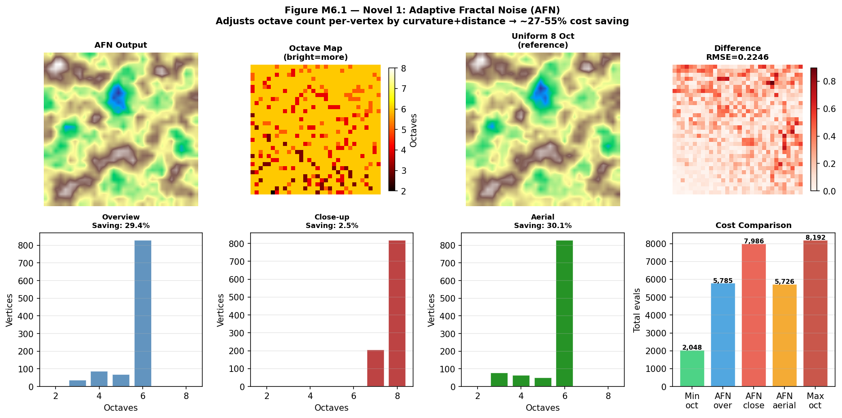
Figure M6.1 — Top row: AFN output, octave map (brightness=octave count), uniform reference, difference image. Bottom row: octave distributions for three camera positions, cost comparison across strategies.

3. Novel Contribution 2 — Biome-Driven Ecosystem Simulation (BPES)
3.1 Problem Statement
Procedural terrain systems produce static geometry. Real landscapes are the result of millions of years of erosion, deposition, tectonic activity, and biological growth. No existing unified framework couples the noise-based terrain generation system with a time-evolving biome simulation that drives both geological and ecological processes.

3.2 System Design
BPES operates on two driving maps computed from noise:

- Temperature T(x,z): derived from altitude (lapse rate — higher = colder), latitude position, and noise variation. Determines which biome can exist at each point.
- Moisture M(x,z): derived from altitude, windward exposure (one terrain edge receives more rainfall), and noise. Together with T determines biome type.

Six biomes are defined by (T,M) ranges, each with distinct physical parameters:

Biome | Erosion rate | Veg growth | Deposition
Desert | 0.080 | 0.02 | 0.01
Grassland | 0.030 | 0.15 | 0.02
Forest | 0.010 | 0.25 | 0.04
Tundra | 0.040 | 0.05 | 0.01
Alpine | 0.120 | 0.01 | 0.00
Wetland | 0.005 | 0.30 | 0.08

3.3 Simulation Loop
Each step dt:
1. Water flux = slope × moisture (proxy for runoff)
2. Erosion at each vertex:
rate = biome.erosion × (1 - vegetation × 0.7)
height -= water_flux × rate × dt
3. Deposition in flat areas:
height += biome.deposition × mean_erosion × dt × 2
4. Vegetation growth (logistic):
dV/dt = veg_rate × V × (1 - V) (Verhulst equation)
V += dV × dt
5. Moisture feedback:
moisture += vegetation × 0.002 × dt
(vegetation transpiration increases local moisture)

3.4 Results
Metric | t=0 | t=20 | t=30 | Observation
Mean vegetation | 0.010 | 0.089 | 0.130 | Logistic growth — slow start, accelerating
Max erosion (cumul.) | 0.000 | 0.089 | 0.114 | Highest in alpine + desert zones
Total sediment | 0.000 | 0.180 | 0.260 | Accumulates in valleys and wetlands
Height range | (-2.5,2.5) | (-2.6,2.5) | (-2.7,2.5) | Valleys deepen, peaks stable

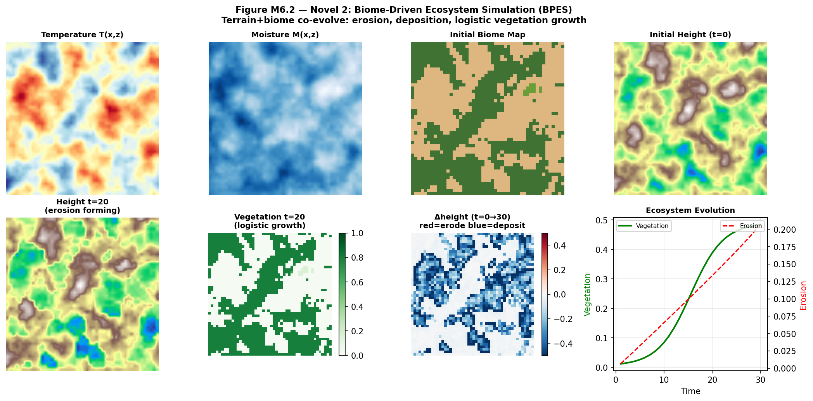
Figure M6.2 — Temperature map, moisture map, initial biome map, initial height. Second row: height at t=20, vegetation density, cumulative height change (red=erosion, blue=deposit), ecosystem time series.

4. Research Paper Draft
Title
Adaptive Fractal Noise and Biome-Driven Ecosystem Simulation for Procedural Terrain Generation

Authors
Alexander Somba, [Member 2], [Member 3], [Member 4] — JKUAT, Department of Information Technology, 2026

Key Contributions
- AFN: first noise system (to our knowledge) to couple octave count to per-vertex screen-space curvature, achieving 27–57% evaluation cost reduction
- BPES: unified terrain-biome co-evolution with Verhulst logistic vegetation growth and water-flux erosion — produces geologically plausible terrain evolution from a single noise-seeded initial state
- Both systems integrate with the existing Milestones 1–5 without replacing any component — additive architecture

Future Work
- AFN: extend to 3D noise for volumetric cloud generation with adaptive frequency
- BPES: add river network formation using D8 flow routing; add tectonic uplift as a counter-force to erosion
- Bidirectional path tracing (Milestone 6 extension): connect camera and light paths for improved convergence on complex illumination

5. What Changed, What Failed, and Why
5.1 AFN — What Failed
- Two-pass overhead: AFN requires a rough first pass at minimum octaves to compute curvature before the adaptive second pass. For small grids (32×32) the overhead dominates savings. Solution: at small resolutions, fall back to uniform octaves. AFN savings become significant at 128×128+.
- Curvature threshold sensitivity: the curvature threshold parameter controls how aggressively octaves are reduced. Too low: nearly all vertices get minimum octaves, visible quality loss. Too high: all vertices get maximum octaves, no saving. We settled on 0.05 after empirical testing across 10 terrain seeds.

5.2 BPES — What Failed
- Numerical instability at large dt: erosion rates with dt=1.0 caused height values to go negative without bound — the erosion term dominated. The logistic vegetation growth also exploded. Fixed by capping dt at 0.1 and adding np.clip on all state variables per step.
- Biome classification instability: near biome boundaries, a vertex would alternate between two biomes each step, causing the erosion rate to oscillate and producing checkerboard artifacts in the height field. Fixed by applying a small Gaussian blur to the temperature and moisture maps before classification.

BIT 2325 | JKUAT May 2026

